SKILL 9 : NOUN CLAUSE CONNECTORS
Noun Clause adalah sekelompok kata (yang punya S+V sendiri!) yang mengambil alih peran si kata benda tadi. Dia bisa jadi Subjek, bisa jadi Objek. Noun Clause Connectors adalah kata-kata yang mengawali sebuah Noun Clause. Mereka mirip dengan beberapa Adverb Connector, tapi fungsinya beda total. Konektor ini menandakan bahwa klausa setelahnya akan berperan sebagai Noun.
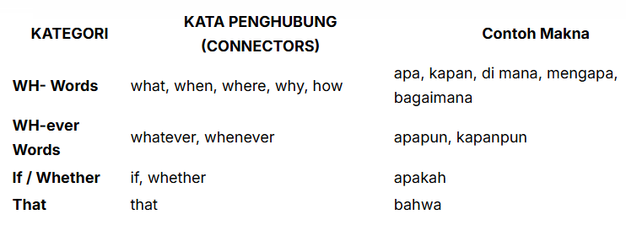
- Sebagai Subjek (di depan Verb utama):Formula: [Connector S + V] Verb (utama)…
- [What he said] was interesting. (Apa yang dia katakan = Subjek)
- [Why she left] is a mystery. (Mengapa dia pergi = Subjek)
- Sebagai Objek (setelah Verb utama atau Preposisi):Formula: S + Verb (utama) [Connector S + V].
- I know [what he said]. (tahu APA? -> apa yang dia katakan = Objek Verb)
- I am thinking about [what he said]. (Objek Preposisi ‘about’)

Latihan
- Why the condition of the patient deteriorated(A) so rapidly(B) it(C) was not explained(D)
  - Why the condition of the patient deteriorated
  - so rapidly
  - it
  - was not explained
- Why(A) he left the meeting(B) early(C) it(D) remains a mystery.
- Why
- he left the meeting
- early
- it
- The professor asked the students what(A) were they(B) doing(C) during the lab(D)
- what
- were they
- doing
- during the lab
- What the students discovered in the lab _______ quite surprising.
- it was
- was
- they were
- were
- The manager needs to know _______.
- when will the meeting start
- when the meeting will start
- when will start the meeting
- the meeting will start when

SKILL 10 : USE NOUN CLAUSE CONNECTORS
konektor Noun Clause adalah “multitasker” yang berfungsi sebagai penghubung dan sekaligus Subjek di dalam klausa itu sendiri. Sebagai contoh, bandingkan dua kalimat ini:
- Skill 9: I know when he will arrive. (Konektor = when, Subjek = he)
- Skill 10: I know who will arrive. (Konektor = who, who juga Subjek dari will arrive)
Kenyataannya, tidak semua Noun Clause Connector bisa merangkap jabatan seperti ini. Sebaliknya, hanya beberapa konektor tertentu yang bisa bertindak sebagai Konektor sekaligus Subjek di dalam klausanya.
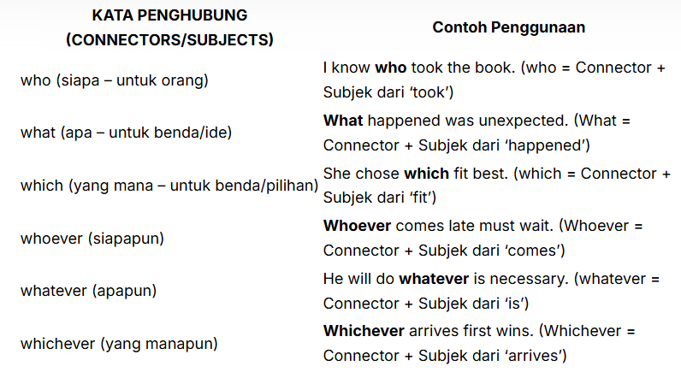
ketika Noun Clause diawali oleh konektor multitasking (who, what, which, whoever, whatever, whichever) dan konektor itu sendiri adalah pelaku aksi atau yang dijelaskan oleh Verb di dalam Noun Clause, maka tidak ada Subjek terpisah lagi. Akibatnya, struktur internalnya langsung menjadi Connector/Subject + Verb. bandingkan lagi aturan berikut ini:
- Skill 9 (Butuh S terpisah): I know where she lives. (Yang ‘lives’ adalah ‘she’, ‘where’ hanya konektor tempat).
- Skill 10 (Connector = S): I know who lives there. (Yang ‘lives’ adalah ‘who’, ‘who’ adalah konektor sekaligus Subjek).

Latihan
- The voters should elect(A) whichever(B) of the candidates(C) it seems(D) best to them
  - should elect
  - whichever
  - of the candidates
  - it seems
- We need to find out who(A) he(B) left(C) the door open(D).
- Who
- He
- Left
- the door open
- Whatever(A) happened(B) yesterday(C) important(D).
- Whatever
- Happened
- Yesterday
- Important
- _______ won the prize will receive a scholarship.
- Who
- The student
- Whoever
- That who
- The researchers are trying to determine _______ caused the unusual phenomenon.
- What
- what it
- it what
- that what

EVALUASI SKILL 9 DAN SKILL 10

- Choose correct or incorrect for the following sentences
- When the season starts is determined by the weather
- Correct
- Incorrect
- The manual how the device should be built
- Correct
- Incorrect
- The schedule indicated if the teams would be playing in the final game
- Correct
- Incorrect
- He refused to enter a plea could not be determined by the lawyer
- Correct
- Incorrect
- Talked about where we should go for lunch
- Correct
- Incorrect
- The game show contestant was able to respond to whatever was asked
- Correct
- Incorrect
- You should find out which the best physics department
- Correct
- Incorrect
- The employee was unhappy about what was added to his job description
- Correct
- Incorrect
- Whoever wants to take the desert tour during spring break signing up at the office
- Correct
- Incorrect
- The motorist was unable to discover who he had struck his car
A. Correct
B. Incorrect
- Choose A, B, C, or D for the incorrect structures from the following sentences
- The police could not determine(A) that who(B) had committed(C) the crime(D).
  - could not determine
  - that who
  - had committed
  - the crime
- It is important to know(A) what is the schedule(B) for(C) the upcoming conference(D).
  - to know
  - what is the schedule
  - for
  - the upcoming conference
- Why did the company decide(A) to relocate(B) its headquarters remains(C) a secret(D).
  - Why did the company decide
  - to relocate
  - its headquarters remains
  - a secret
- The witness stated(A) that(B) what did she see(C) during(D) the incident.
- Stated
- that
- what did she see
- uring
- Whether(A) the new policy it will be(B) effective or not(C) is(D) still under discussion.
- Whether
- it will be
- or not
- is
- The manager will promote(A) whoever he(B) completes(C) the training program successfully(D).
- will promote
- whoever he
- completes
- uccessfully
- What it(A) was written in the ancient manuscript(B) is(C) difficult to decipher(D).
- What it
- in the ancient manuscript
- is
- to decipher
- The committee must choose(A) which(B) proposal it seems(C) most promising(D).
- must choose
- which
- it seems
- most promising
- We(A) are unsure about(B) who he(C) is responsible for(D) the security breach
- We
- About
- who he
- for
- Whatever(A) are presented during(B) the conference should be(C) relevant(D) to the main topic.
- Whatever
- During
- should be
- relevant

- Choose A, B, C, or D for the correct answer
- was responsible for the mistake is still unknown.
  - Who
  - The person who
  - It was who
  - That who
- The professor explained dinosaurs became extinct.
- how did
- how
- how that
- how dinosaurs
- We are concerned about the project on time.
- whether they will finish
- will they finish
- whether will they finish
- they will finish
- the proposal requires further revision is clear.
- Because
- Although
- That
- What
- I need to find out .
- where is the nearest post office
- where the nearest post office is
- the nearest post office is where
- is where the nearest post office
- The police are investigating caused the accident on the highway.
- What
- what it
- it what
- that what
- arrives first will get the best seat.
- Who
- The person
- Whoever
- It is who
- We need to decide is the most suitable option for the project.
- it which
- which
- which it
- that which
- was discussed in the meeting remains confidential.
- What
- It was what
- That
- What it
- She will accept is offered to her.
- Whatever
- That
- whatever it
- it

